# Sir Syed University of Engineering & Technology (SSUET)

# Software Engineering Department

***Course Name: Deep Learning***

***Semester: 6th***

***Batch: 2021F***

***Section: “B”***

**PROJECT REPORT**

***Project Title:*** ***Driver Safety Management System***



***Submitted To:***

***Miss Sanober Soomro***

***Submitted By:***

**RAFIA KIRAN 2021F-SE-053**

**WAJEEHA AKHTER 2021F-SE-283**

**ZAINAB KHAN 2021F-SE-056**

**TEAM PROFILE**

1. **RAFIA KIRAN (2021F-SE-053)**

(Development and Testing)

1. **WAJEEHA AKHTER (2021F-SE-283)**

(Development and Documentation)

1. **ZAINAB KHAN (2021F-SE-056)**

(Gathered information and Testing)

**TABLE OF CONTENTS**

|  |  |  |
| --- | --- | --- |
| S. No. | TOPICS | PAGE No. |
| 1 | PROBLEM DOMAIN | 4 |
| 2 | PROPOSED TREATMENT | 4 |
| 3 | PLAN OF WORK | 4 |
| 4 | PROJECT SCHEDULING | 4 |
| 5 | SOFTWARE AND HARDWARE SPECIFICATIONS | 5 |
| 6 | BLOCK DIAGRAM | 5 |
| 7 | SYSTEM FLOW DIAGRAM | 5 |
| 8 | USER GUIDE | 6 |

## **1. PROBLEM DOMAIN:**

The project focuses on implementing a Driver Safety Management System with a specific emphasis on eye closure detection. In the context of road safety, the system triggers an alarm when it detects the user's eyes are closed, simultaneously sending notifications to relevant authorities. The primary goal is to promptly address potential instances of driver fatigue, minimizing the risk of accidents.

## **2. PROPOSED TREATMENT:**

To achieve the project objectives of detecting closed eyes and ensuring road safety, the proposed solution involves utilizing computer vision algorithms. The system will employ a camera to continuously monitor the driver's face and analyze facial features, specifically focusing on eye closures. When the system identifies prolonged eye closure as an indicative of potential driver fatigue, it triggers an alarm within the vehicle. Simultaneously, it sends notifications to authorities. This integrated approach aims to proactively address instances of drowsy driving, enhancing overall road safety.

## **3. PLAN OF WORK:**

The project will commence with thorough research on existing driver monitoring technologies and computer vision algorithms tailored for eye closure detection. Subsequently, tasks will be divided into key components, such as algorithm development, hardware integration (camera system), and software implementation.

# 4. PROJECT SCHEDULING:

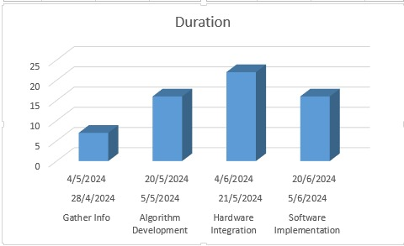

## 

## **5. SOFTWARE AND HARDWARE SPECIFICATION**

* Hardware Requirements:
  + Processor: 2Ghz or more
  + Hard Drive: 256 GB or more
  + Memory (RAM): 4GB or more
  + Camera
* Software Requirements:
  + Windows 11
  + PyCharm ,Thonny

**6. BLOCK DIAGRAM**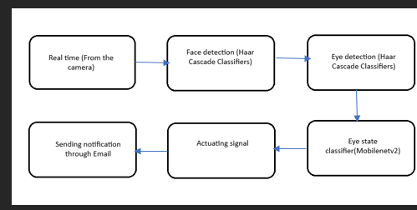

# 7. SYSTEM FLOW DIAGRAM:

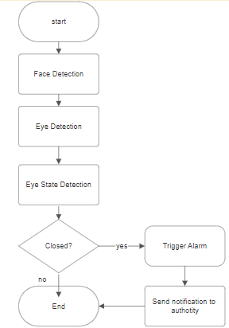

**8. USER GUIDE:**

* The light should be proper on driver’s face to detect his face & eyes.
* Camera should be properly set so it can detect face & eyes

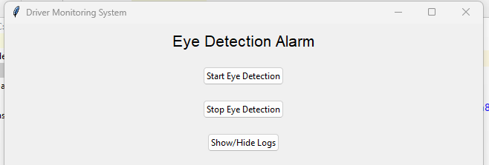

* Click on Start Eye Detection BUTTON , to detect face.
* Then it will detect eyes

* After that it will classify whether the eyes open or close

* Now it triggers Alram.



* And last it sends mail to authority.

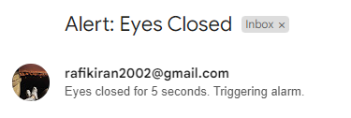

## **REFERENCES:**

# Guide to Haar Cascade Algorithm with Object Detection Example:

<https://www.analyticsvidhya.com/blog/2022/04/object-detection-using-haar-cascade-opencv/>

<https://stackoverflow.com/questions/55952999/mobilenetv2-in-tf-keras-many-links-but-no-useful-informa>

**Test and Train data from:**

https://www.kaggle.com/

**Email**:

https://mail.google.com/mail/u/0/#inbox